User Guide — The Translator

The Translator — User Guide

Overview
The Translator lets you upload documents and receive translated versions that preserve original formatting. It supports many file types and languages.
──────────────────────────────────────────────────

Supported File Types
- PDF (.pdf)
- Word (.docx)
- PowerPoint (.pptx)
- Plain Text (.txt)
Maximum file size: 20 MB
──────────────────────────────────────────────────

How to Use

Step 1: Select Target Language
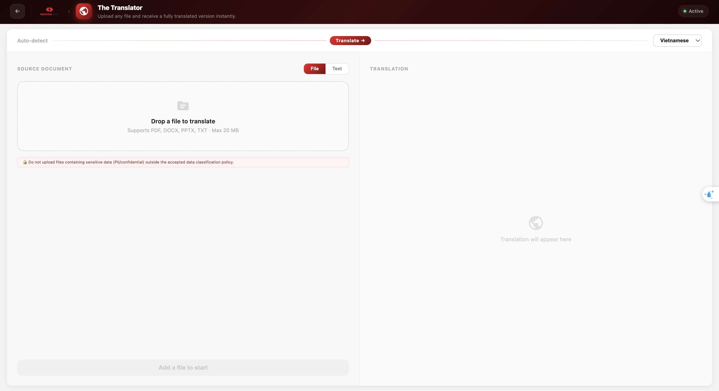
At the top, a language bar shows the source language (auto-detected). Use the right dropdown to choose the target language (target language – Vietnamese or English).

Step 2: Upload Your Document
On the left panel (“Source Document”), drag and drop your file into the dropzone or click to browse. The filename then appears.
> ⚠️ PII Notice: Do not upload documents containing sensitive personal information.
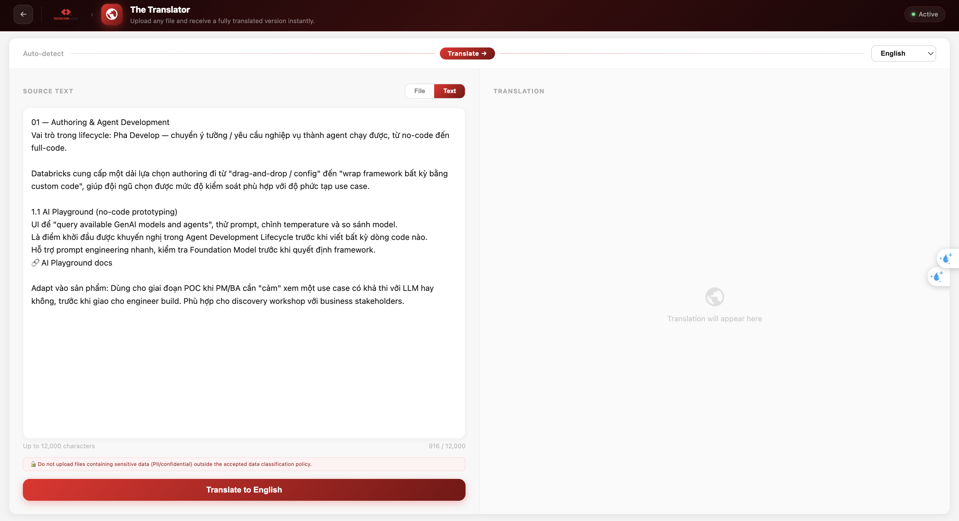
*Note*: Two methods add data—upload a file or input text manually.

Step 3: Start Translation
For upload file pdf, the interface provides a draggable control for the input document, along with a toggle button group to select the output format (PDF or DOCX).
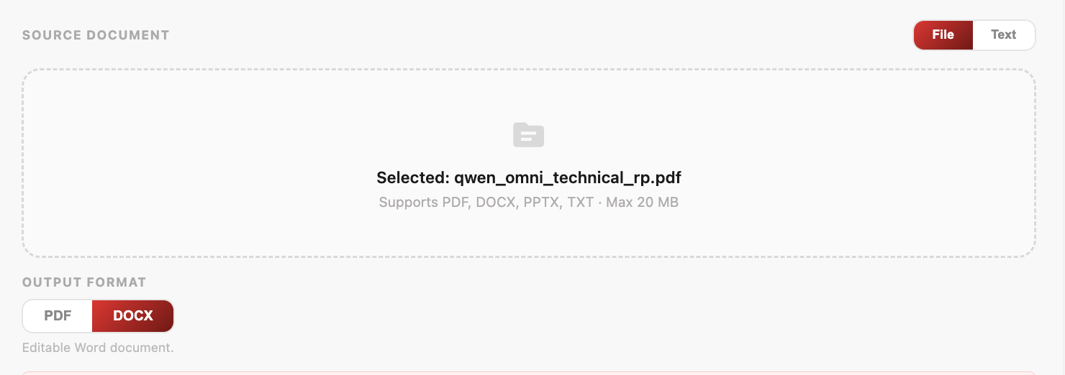
*Note:* The selected output format is only visible when a PDF file is uploaded; it will not appear for other file types.
Click the "Translate to [Language]" button at the bottom of the left panel. The button enables after a file is selected.
Two languages are currently supported: Vietnamese and English.

Step 4: Monitor Progress
The right panel (“Translation”) shows real‑time progress:
- Upload — File is being sent to the server
- Translate — AI translates chunk by chunk (progress bar shows percentage and estimated time).
- Build — Final translated file is assembled.
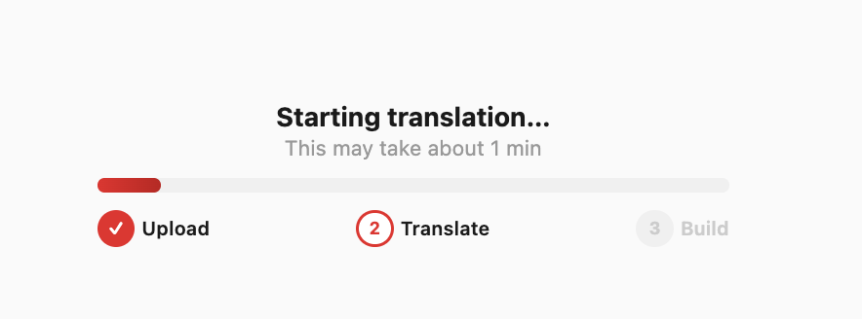
You’ll see: - Current step indicator (Upload → Translate → Build) - Progress bar with percentage - Estimated time remaining (e.g., "Step 3 of 12 · About 2 min left").

Step 5: Download or Copy Result
Once complete:
- For structured files (PDF, DOCX, PPTX): A download card appears with a "Download ↓" button. The output format matches the input (PDF → DOCX, DOCX → DOCX, PPTX → PPTX).
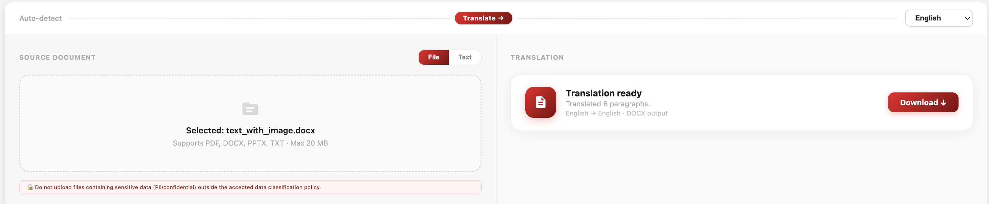
- For plain text: The translated text appears in the panel with Copy and Download buttons.
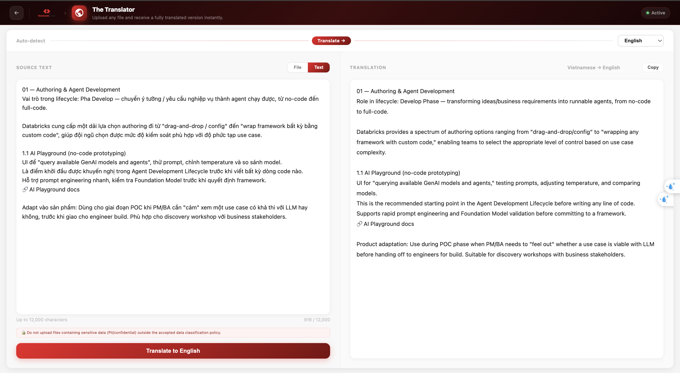
──────────────────────────────────────────────────

Tips
- The translator uses a hybrid LLM strategy: fast model (Haiku) for short content like titles and labels, powerful model (Sonnet) for complex paragraphs. This optimizes speed and quality.
- Translating large documents (50+ pages) may take several minutes; the progress indicator shows real‑time status.
- If a document is too large, it may be truncated — a warning banner will indicate how many characters were translated.
- Cancel a long translation by refreshing the page (the server continues processing but the UI resets).
──────────────────────────────────────────────────

Limitations
- Maximum file size: 20 MB
- Supported formats: PDF, DOCX, PPTX, TXT only
- Domain‑specific terminology (legal, medical, financial) may need human review
- PDF output is converted to DOCX format (PDF → DOCX)
- Translation timeout: 10 minutes maximum
- Upon page refresh, the progress information or translated file is no longer visible in the user interface
──────────────────────────────────────────────────
Last updated: 2026-05-25

